Cricsheet Match Analysis – Documentation
Selenium Scraper
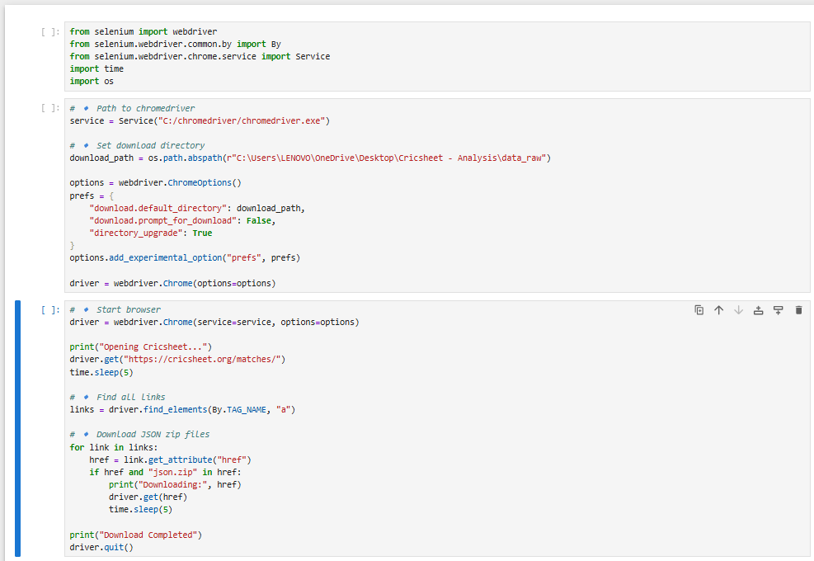

Json Files
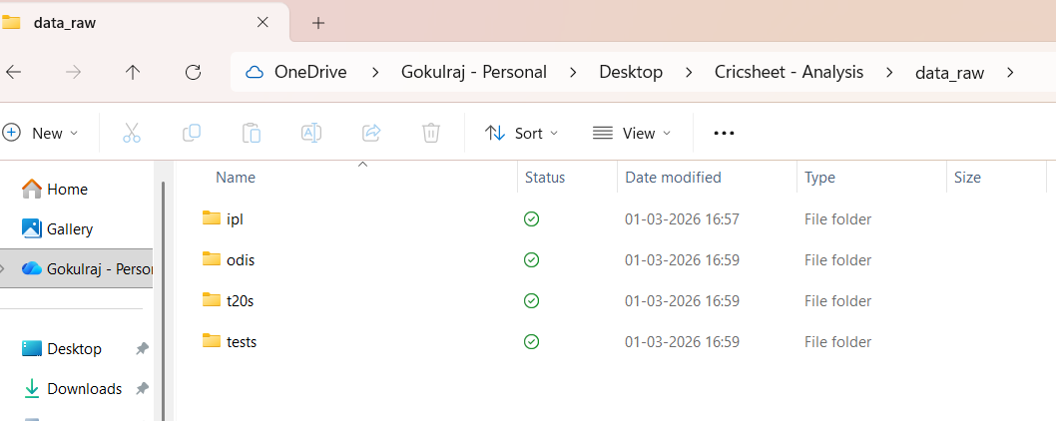
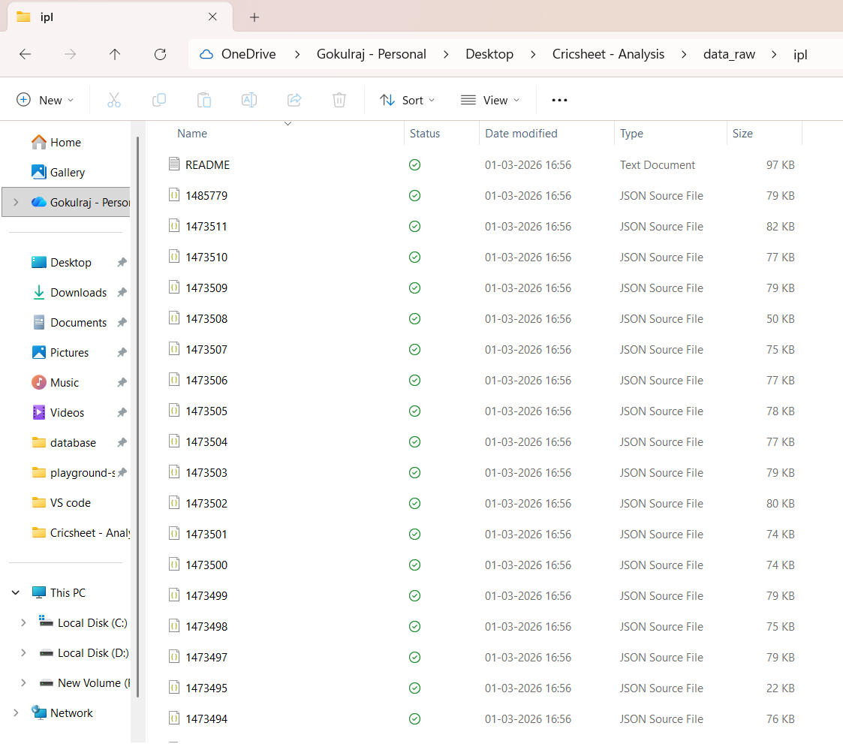

JSON Parsing & Data Transformation
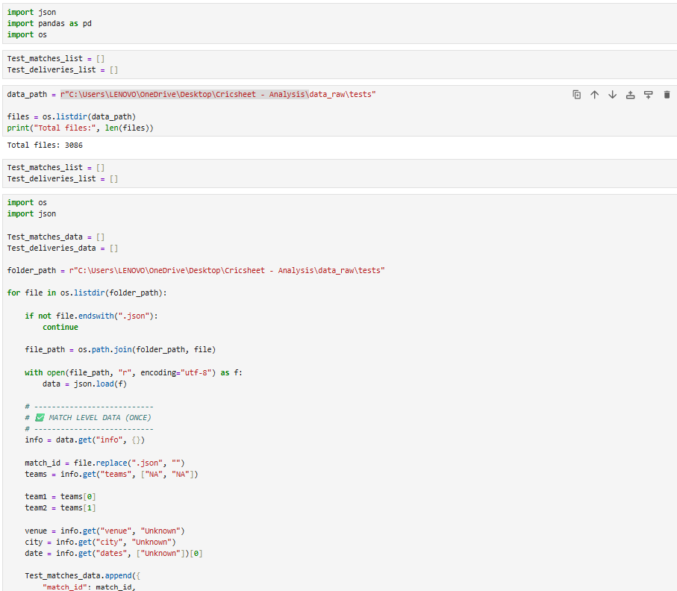
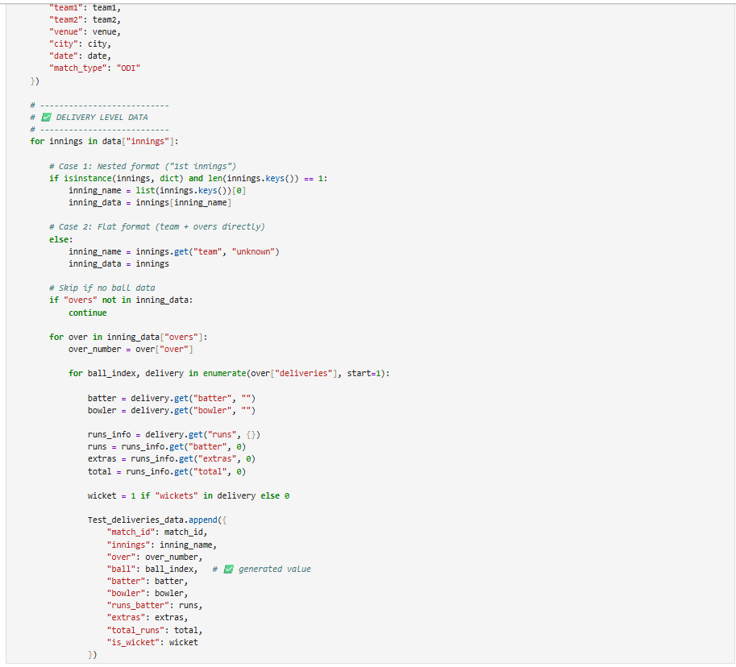
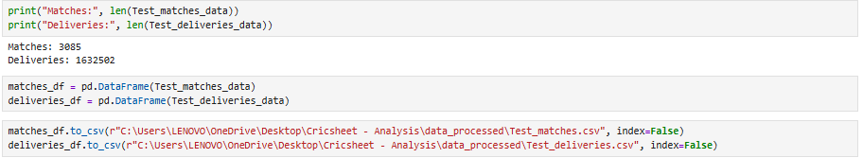
Expected Output after extraction and cleaning of datasets
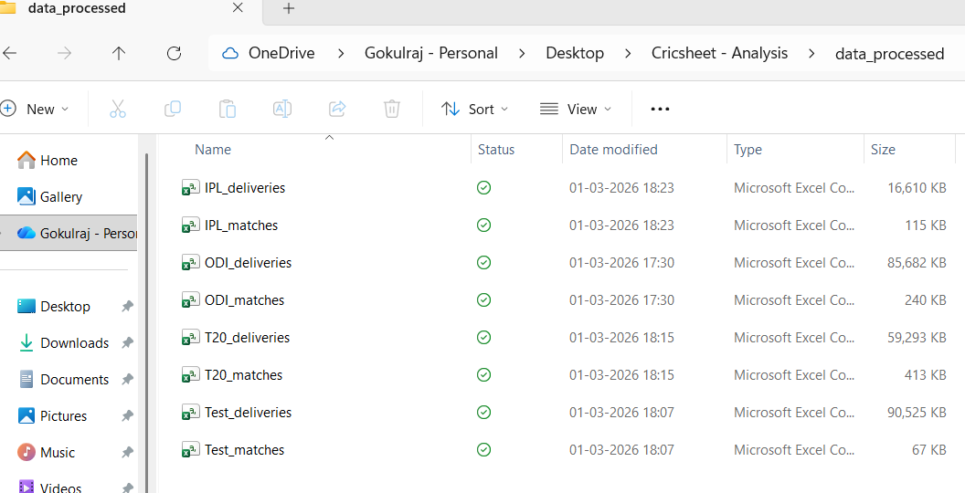
Loading Data into Database and Starting Analytics
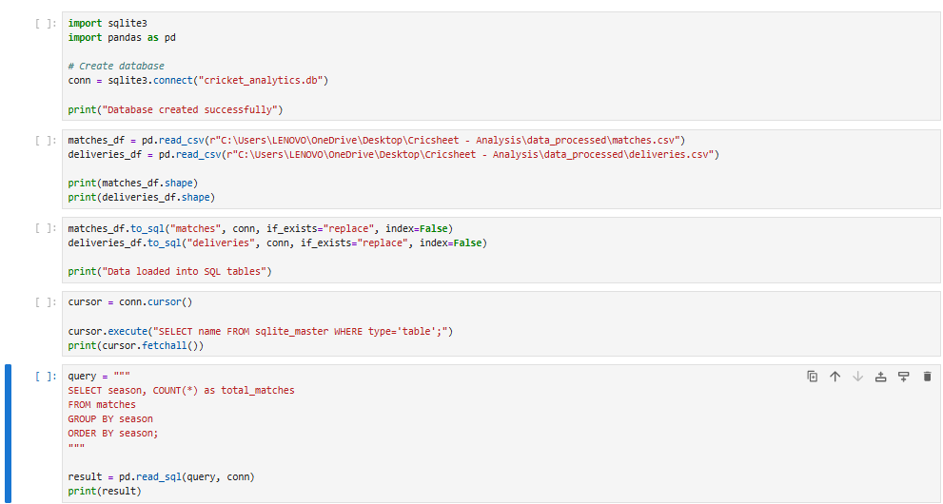
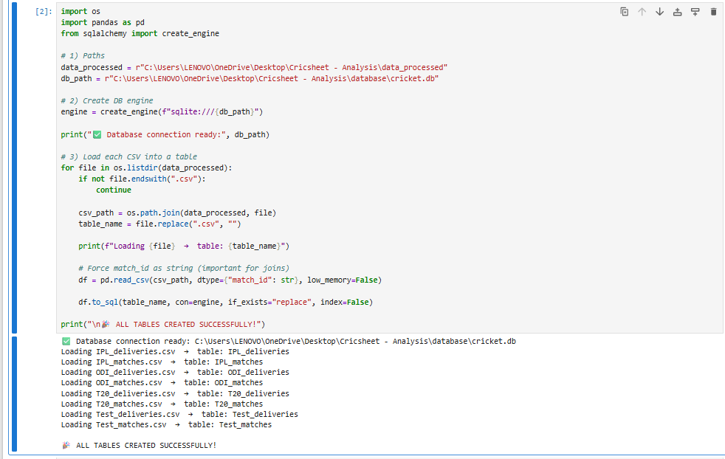
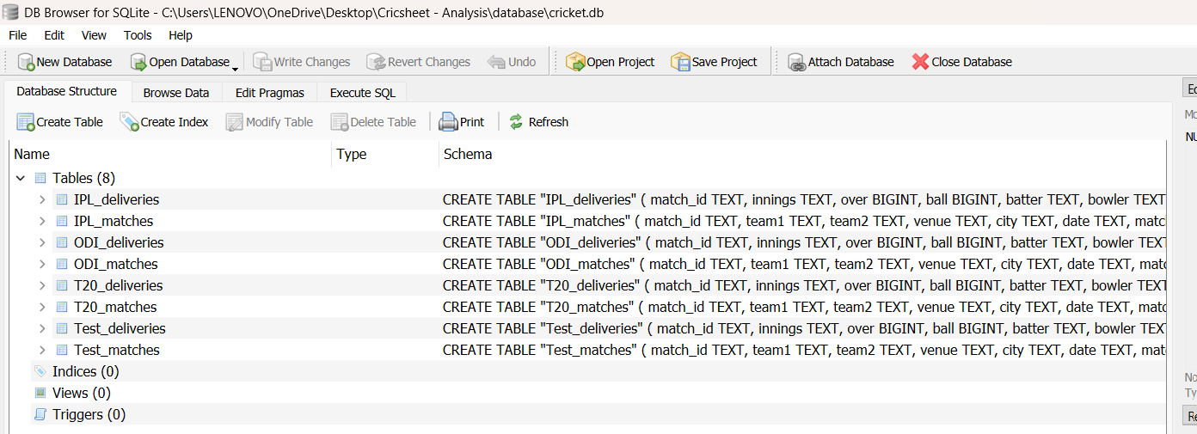
Insights of SQL
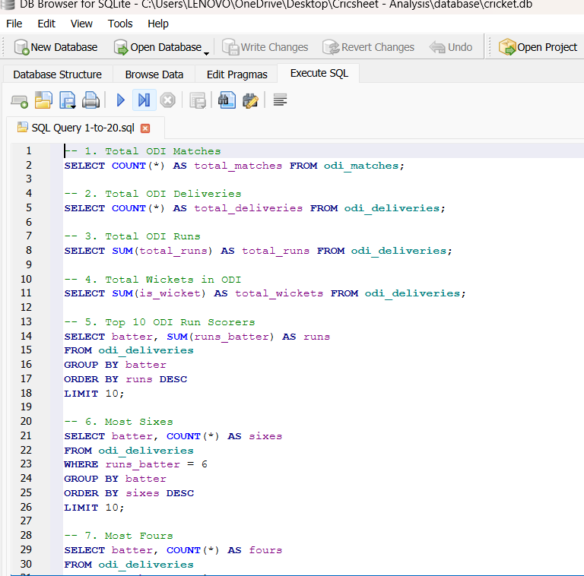
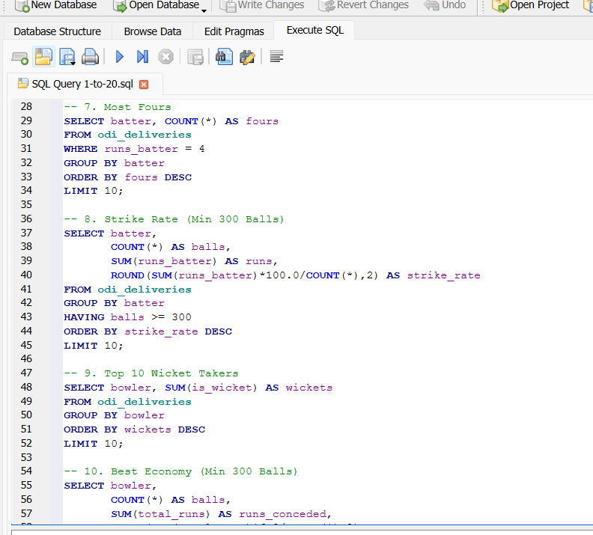
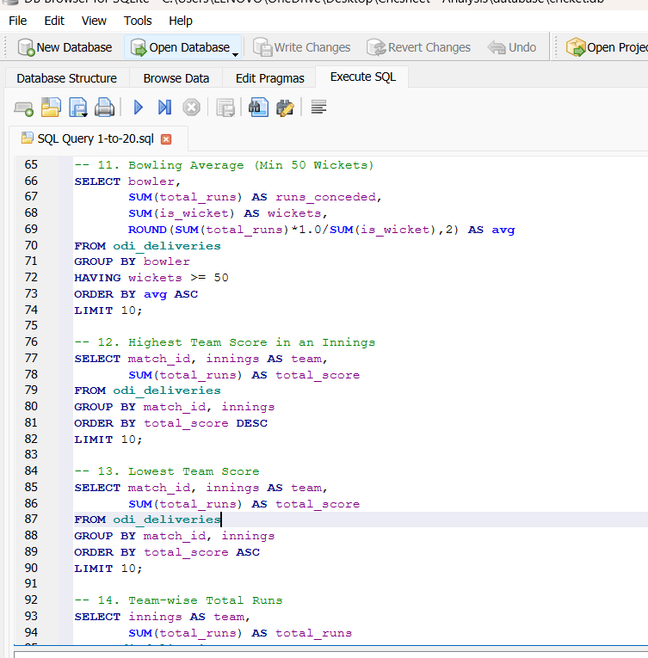
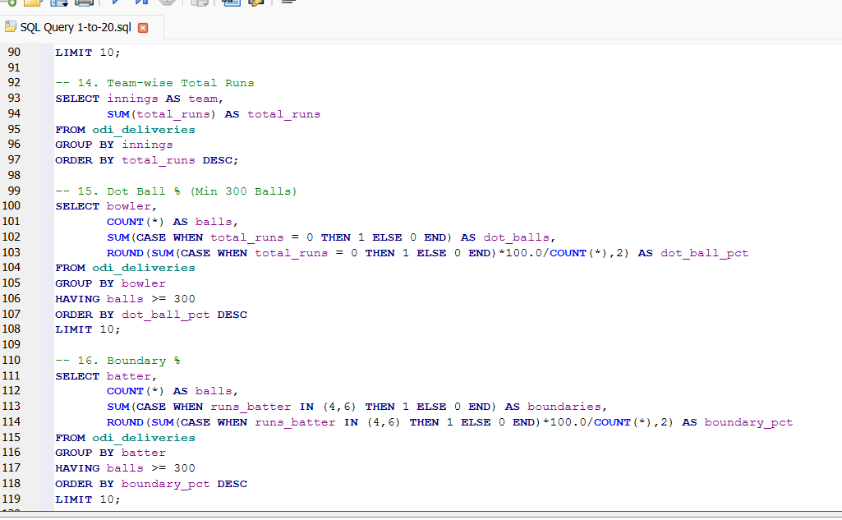
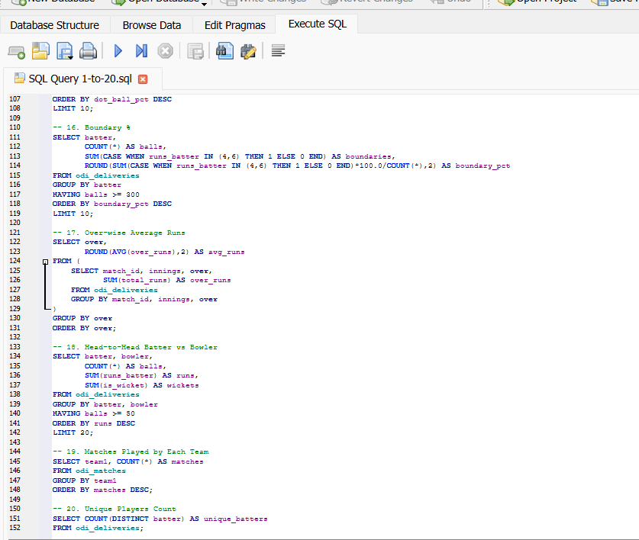

Power BI Dashboard
Datasets load in Power BI
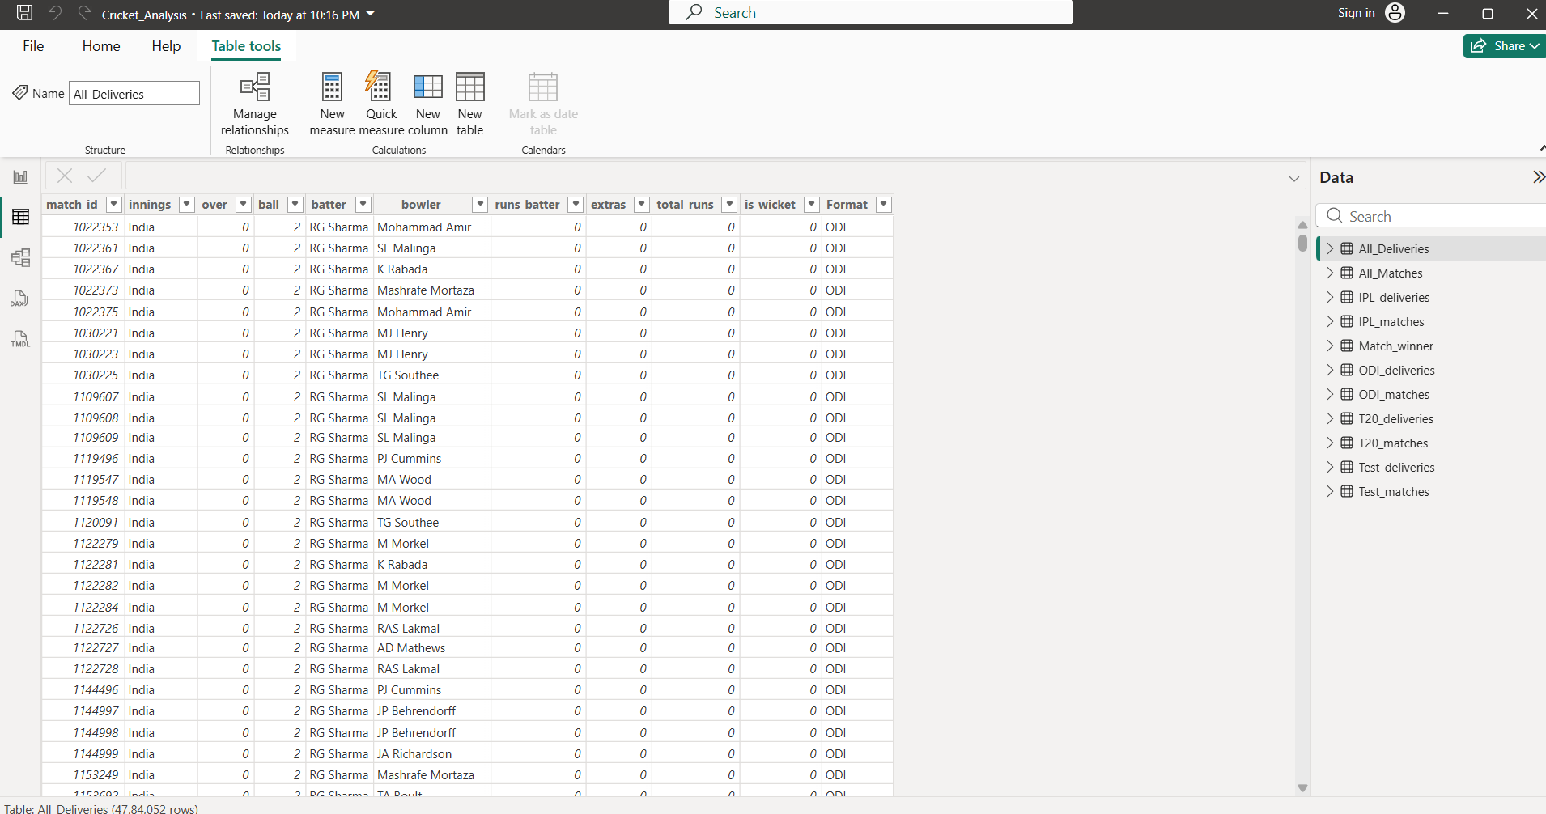

Model view
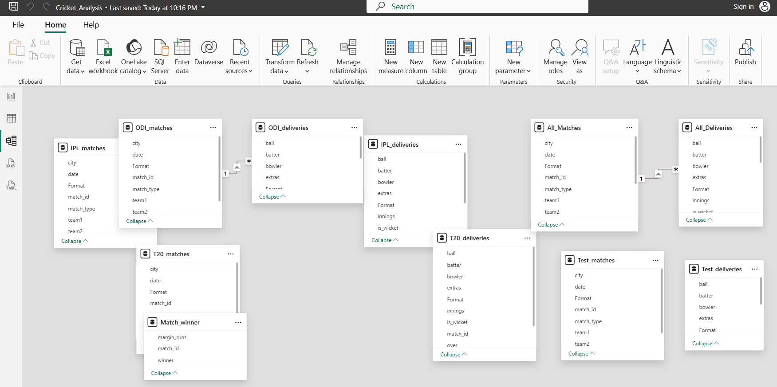

Report View
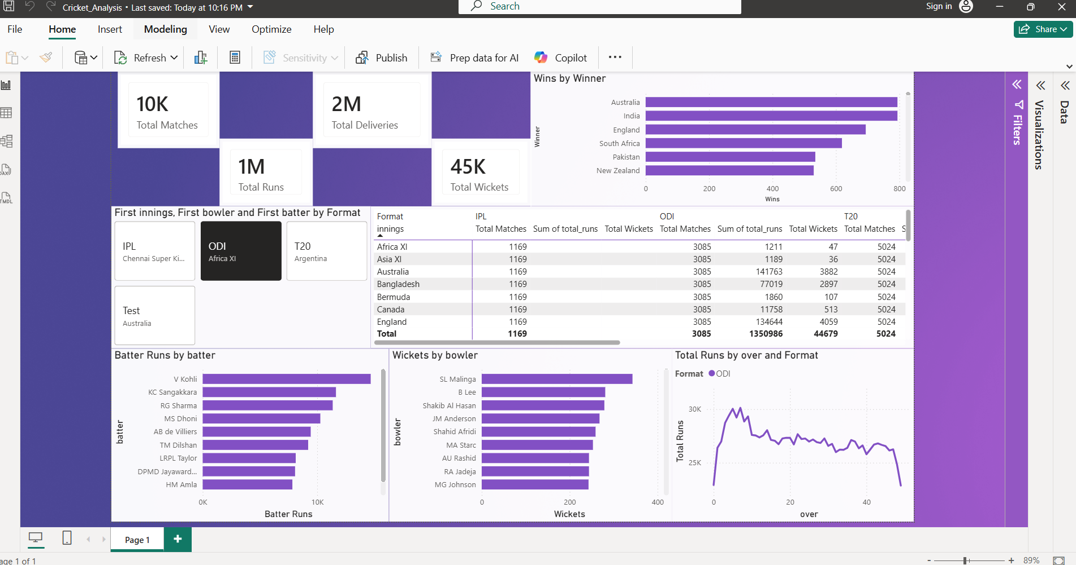

Conclusion:
This project is an interactive Cricket Analysis Dashboard built using Power BI. The dashboard combines IPL, ODI, T20, and Test match datasets to analyze total matches, runs, wickets, deliveries, winning teams, batter performance, bowler statistics, and over-wise run trends. Data was cleaned, transformed, appended, and modeled using Power Query and DAX measures to create dynamic and interactive visualizations for cricket performance insights.

